LAB 1: Understanding ORM with a Retail Inventory System

- What is ORM?
Solution:
ORM (Object-Relational Mapping) is a technique that allows developers to interact with a relational database using object-oriented programming concepts. Instead of writing raw SQL queries, developers can work with C# classes and objects, and the ORM automatically handles translating these operations to SQL.

ORM Maps C# Classes to Database Tables:
Each C# class corresponds to a table in the database.
Each property of the class corresponds to a column in that table.
Each instance of the class represents a row in the table.

Benefits of ORM:
Productivity: Reduces the need to write boilerplate SQL queries.
Maintainability: Changes in the database schema can be easily managed through C# code.
Abstraction: Developers can work with C# objects and rely on the ORM to handle SQL under the hood.

- EF Core vs EF Framework:
Solution:
Feature | EF Core | EF Framework (EF6)
Platform | Cross-platform (.NET Core/.NET) | Windows-only (.NET Framework)
Lightweight | Yes | No
Modern Features | LINQ, async queries, compiled queries | Fewer modern features
Performance | Better due to optimizations | Slower
Flexibility | More flexible and extensible | Less flexible
Maturity | Newer, still evolving | More mature, stable

- EF Core 8.0 Features:
Solution:
EF Core 8.0 introduces several powerful features:

JSON Column Mapping: Store and query JSON data directly within relational columns.
Compiled Models: Improve performance by precompiling the model at build time.
Interceptors: Customize and intercept EF Core operations like queries or commands.
Improved Bulk Operations: Better handling of batch inserts, updates, and deletes.
These features make EF Core 8.0 highly efficient and flexible for enterprise-level applications.

LAB 2: Setting Up the Database Context for a Retail Store
Scenario: The retail store wants to store product and category data in SQL Server.
Objective: Configure DbContext and connect to SQL Server.
Solution:
This page was made in Visual Studio 2022
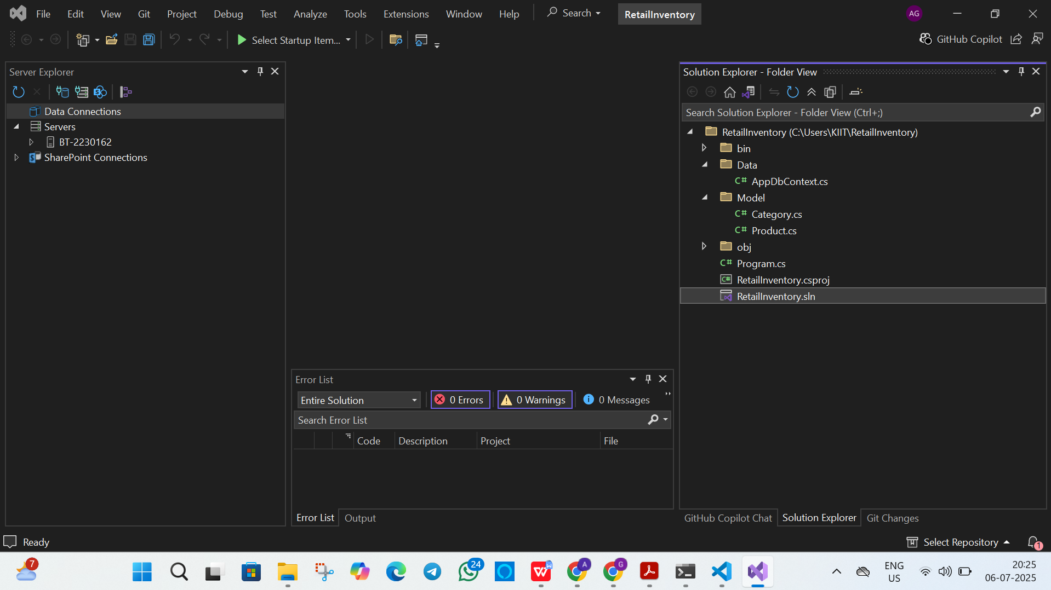

LAB 3: Using EF Core CLI to Create and Apply Migrations
Scenario: The retail store's database needs to be created based on the models you've defined. You’ll use EF Core CLI to generate and apply migrations.
Objective: Learn how to use EF Core CLI to manage database schema changes.
Solution:
Database with tables created:
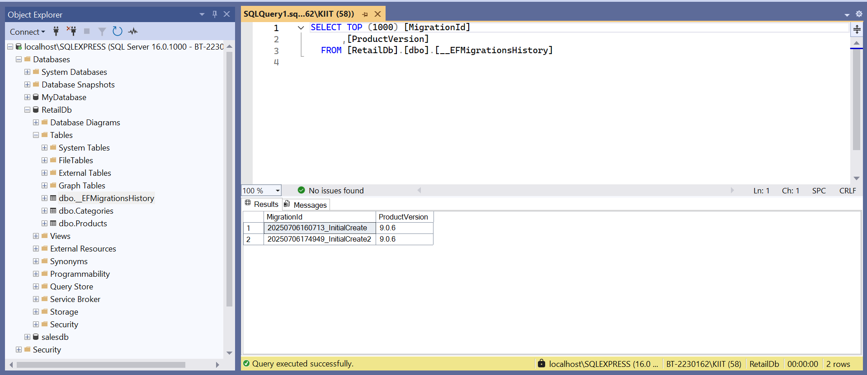

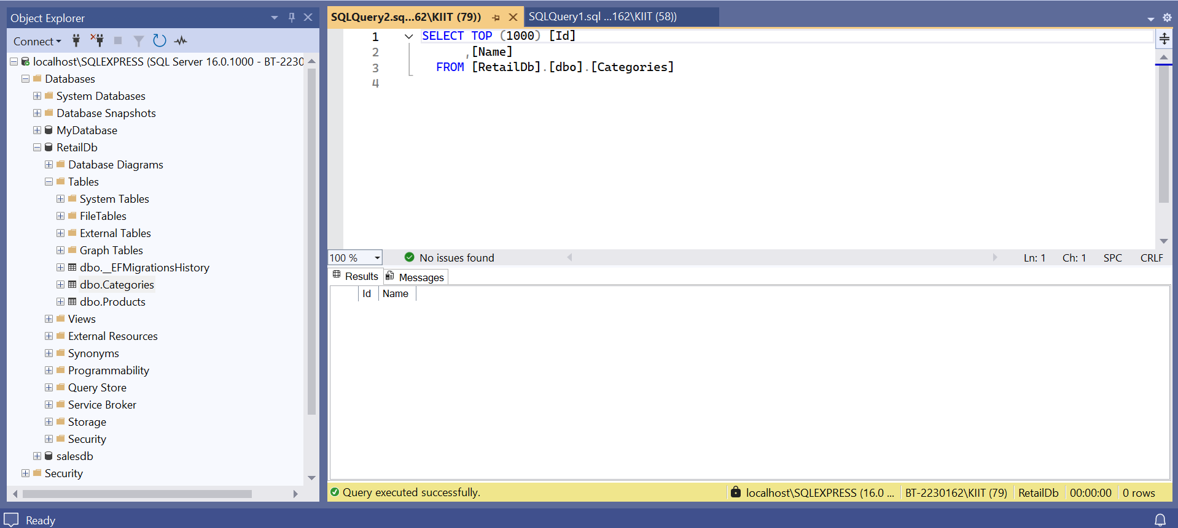

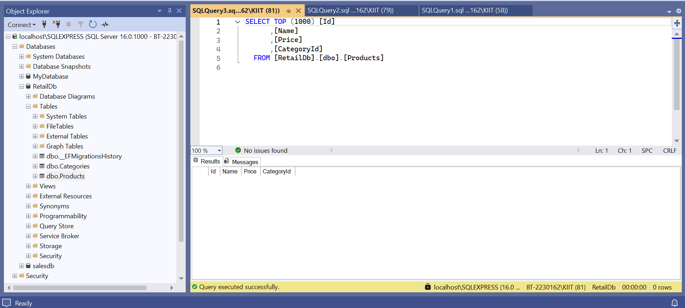

LAB 4: Inserting Initial Data into the Database
Scenario: The store manager wants to add initial product categories and products to the system.
Objective: Use EF Core to insert records using AddAsync and SaveChangesAsync.

Solution:
Updated databses
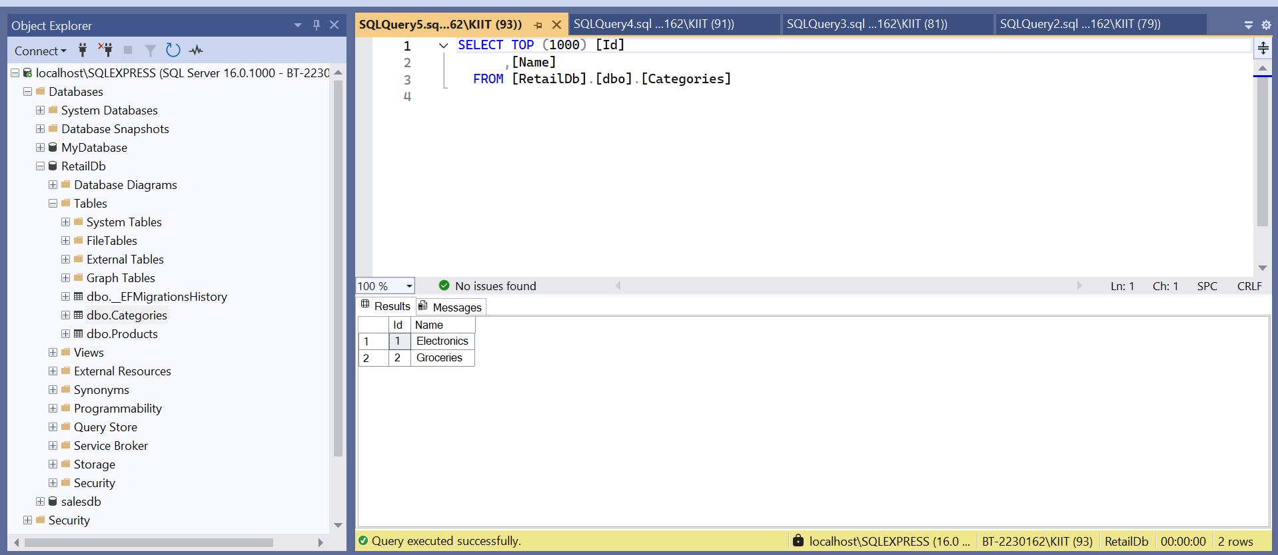

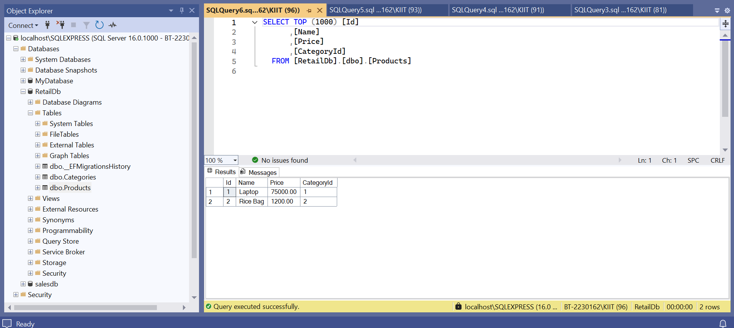

LAB 5: Retrieving Data from the Database

Scenario: The store wants to display product details on the dashboard.
Objective: Use Find, FirstOrDefault, and ToListAsync to retrieve data.

Solution:
